Java Generics is a powerful feature that allows developers to write type-safe and reusable code. When designing and implementing generics in Java, there are several common patterns and use cases that help in creating robust and maintainable applications. Let's explore some generic design implementations:

1. Generic Classes
A Generic Class is a class that operates on a parameterized type. This enables the class to work with different data types without having to write specific implementations.

Example: Generic Box
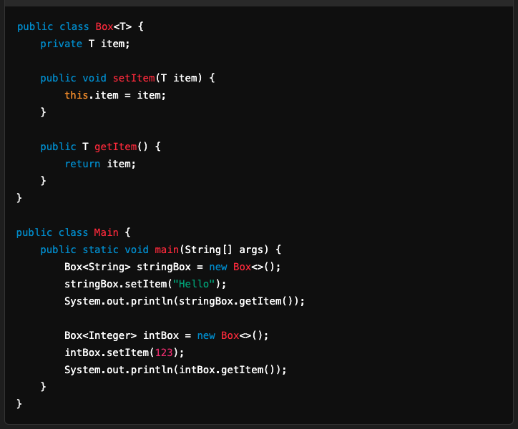

2. Generic Interfaces
A Generic Interface allows implementations to define the type of the interface at runtime.

Example: Generic Comparable
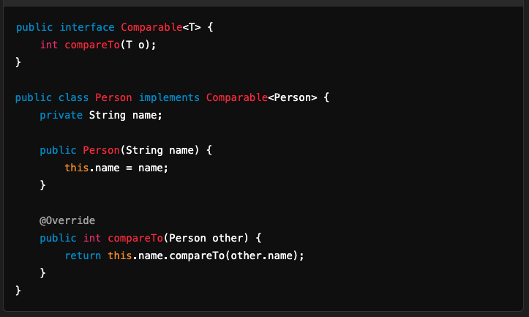

3. Generic Methods
A Generic Method is a method that can operate on different types specified at the time of invocation.

Example: Generic Method for Swapping Elements
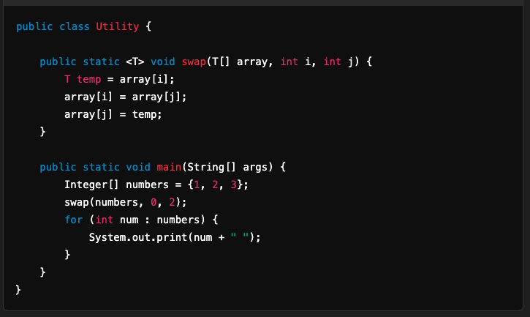

4. Bounded Type Parameters
Bounded type parameters restrict the types that can be passed as arguments to a generic type.

Example: Bounded Generic Method
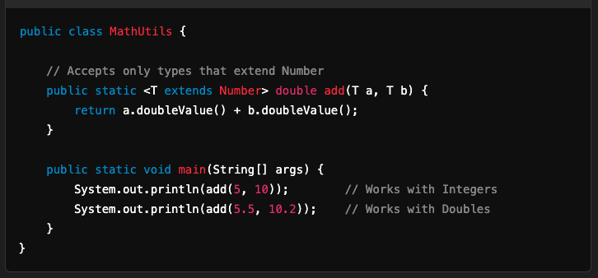

5. Wildcards in Generics
Wildcards (?) represent an unknown type and provide flexibility in generic programming.

Use Cases of Wildcards
- Upper Bounded Wildcards (? extends Type):
  - Used when you want to read data but not modify it.
  - Example: List<? extends Number>.
- Lower Bounded Wildcards (? super Type):
  - Used when you want to write data but do not care about its exact type.
  - Example: List<? super Integer>.

Example: Wildcard Usage
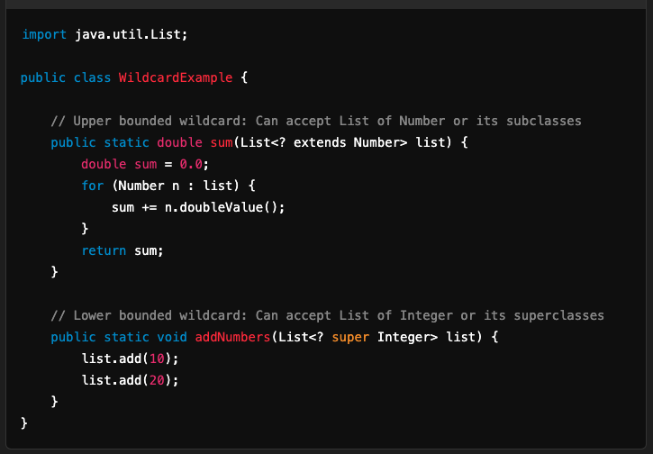

6. Generic Collections
Java's Collections Framework heavily uses generics for type safety and reusability.

Example: Generic Map
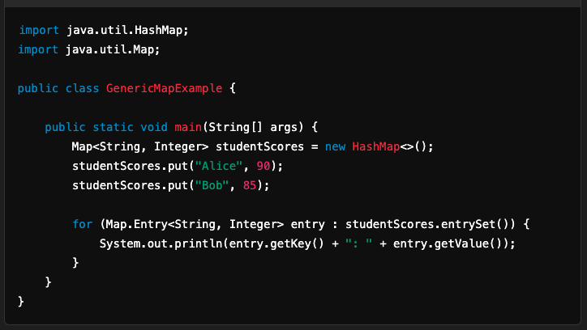

7. Dependency Injection with Generics
Generics can be used to create flexible and reusable service classes, commonly found in dependency injection frameworks like Spring.

Example: Generic Repository
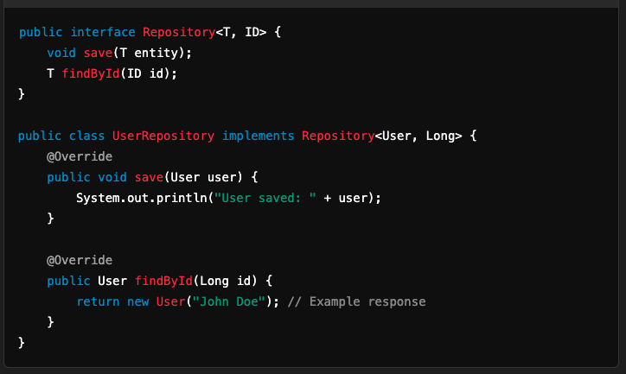

8. Generic Builders
Builders can be implemented generically for flexible object construction.

Example: Generic Builder
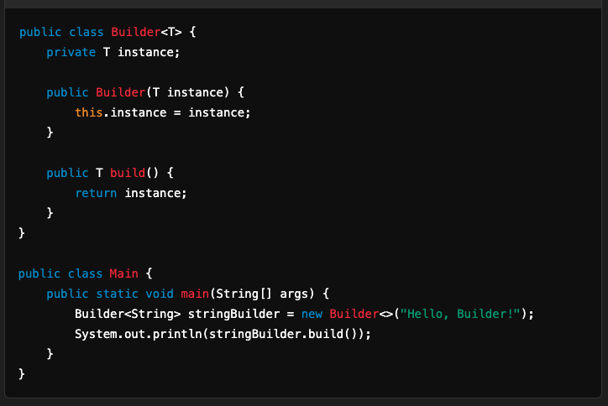

9. Inheritance and Generics
Generic classes can be extended, by maintaining or altering type parameters.

Example: Extending Generic Classes
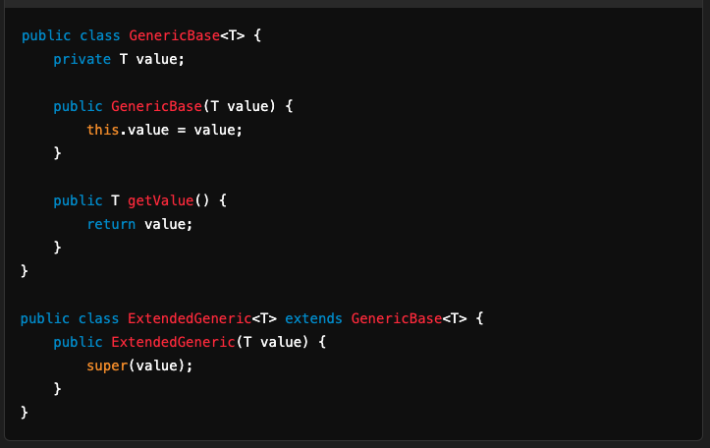

10. Generic Enum Types
Enums can also work with generics for advanced use cases.

Example: Enum with Generics
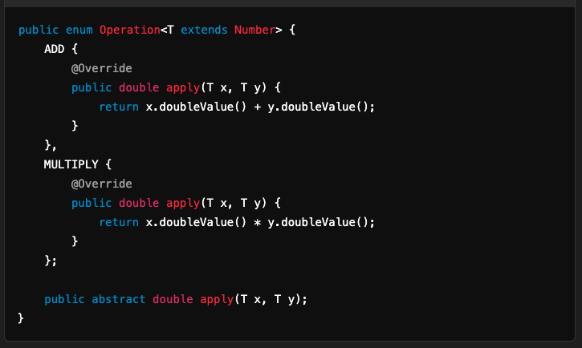

Best Practices for Using Generics
- Avoid Raw Types: Always specify the type to ensure type safety.
- Use Wildcards Judiciously: Use ? extends and ? super where appropriate.
- Combine Generics with Functional Interfaces: Combine generics with Java 8 features like lambdas and streams for concise code.
- Follow Type Parameter Naming Conventions:
  - T: Type.
  - E: Element (used in collections).
  - K, V: Key, Value (used in maps).
  - N: Number.
  - R: Return type.

Generics help write more reusable, flexible, and type-safe code, enhancing the robustness of Java applications.

